PROJECT REPORT :

‘LIFEOS’
INTELLIGENT PERSONAL RESOURCE OPTIMIZER
A Java-Based Student Time and Budget Decision Support System
SUBMITTED BY :
Rachita Patel
REG.NO.:
25BAI11492
BRANCH :
B.Tech Computer Science Engineering (AI & ML)
Academic Year :
2026–27
PROJECT REPOSITORY LINK :
https://github.com/rachitap2005-lgtm/LIFEOS-Intelligent-Personal-Resource-Optimizer.git
DECLARATION:

I hereby declare that the project entitled LIFEOS – Intelligent Personal Resource Optimizer is my work that was created as part of the Java programming project, at VIT Bhopal University.
LIFEOS – Intelligent Personal Resource Optimizer has been developed using Java. Shows how object-oriented programming ideas, collections, exception handling, modular programming, task prioritization, budget management and decision support can be applied in real life.
I further declare that the work shown in this report was completed by me for reasons and has not been submitted elsewhere for any other academic award or qualification.

Name: Rachita Patel
Reg. No.: 25BAI11492
Branch: B.Tech Computer Science Engineering (AI & ML)
Academic Year: 2026–27
Date: 12/09/2025

INTRODUCTION :
In today’s academic environment, students often need to manage multiple tasks, deadlines, available study time, and personal expenses at the same time. Managing these resources manually can make it difficult to decide which task should be completed first or whether a particular expense is affordable within the available budget.
LIFEOS – Intelligent Personal Resource Optimizer is a Java-based student decision-support system designed to help students manage their tasks, time, and budget in an organized manner. The system analyzes task-related factors such as importance, difficulty, estimated completion time, and days remaining to calculate a priority score for each task.
The system also provides a budget management module that maintains the student's monthly budget and records expenses. It calculates the total amount spent and the remaining budget, helping the user understand their current financial position.
One of the main features of LIFEOS is its Smart Plan Generator. Based on the available study hours and calculated task priorities, the system suggests which tasks should be completed and which tasks should be postponed. The project also includes a What-If Analyzer, which allows the user to evaluate the effect of an additional expense on the remaining budget.
The project follows a modular object-oriented design using separate classes for student data, tasks, expenses, budget management, decision-making, and what-if analysis. This makes the system easier to understand, maintain, and extend in the future.
Overall, LIFEOS demonstrates how Java programming concepts can be applied to develop a practical system that supports resource management and decision-making for students.

PROBLEM STATEMENT :
Students often need to manage academic tasks, deadlines, limited study hours and personal expenses at once.
Without a system students find it hard to decide which tasks deserve priority and how to allocate study hours efficiently.
Traditional methods, like keeping notes manually calculating deadlines or tracking expenses do not give students a clear view of their available resources.
As a result important tasks may be delayed study hours may be. Extra expenses may exceed the budget.
The problem addressed by LIFEOS – Intelligent Personal Resource Optimizer is to develop a simple Java-based system that combines task prioritization, time allocation, budget monitoring, and decision analysis in a single application.

Objectives of the System :-
- To calculate the priority of tasks using factors such as importance, difficulty, estimated hours, and remaining days.
- To display and manage the student's current task information.
- To calculate total expenses and the remaining budget.
- To generate a study plan according to available hours and task priorities.
- To analyze whether an additional expense can be accommodated within the remaining budget.
- To provide clear and useful decision-oriented results through a simple console interface.
The proposed system provides a structured approach to managing limited student resources and supports better day-to-day planning and decision-making.

FUNCTIONAL REQUIREMENTS :

Describe the specific features and capabilities provided by the LIFEOS – Intelligent Personal Resource Optimizer. The system consists of multiple functional modules and follows a clear input-processing-output workflow.
Major Functional Modules :-
1. Task Management and Prioritization Module
This module manages student tasks and calculates their priority based on:
- Task name
- Difficulty
- Importance
- Estimated completion hours
- Days remaining
The calculated priority helps the system determine which task should be handled first.
2. Budget and Expense Management Module
This module manages the student's monthly budget and expenses. It:
- Stores expense category and amount.
- Calculates total expenses.
- Calculates the remaining budget.
- Validates expense values.
3. Decision Support and Smart Planning Module
This module uses task priorities and available study hours to generate a practical study plan. It identifies tasks that can be completed within the available time and marks other tasks for postponement.
4. What-If Analysis Module
This module evaluates the effect of an additional expense on the remaining budget. It determines whether the expense is affordable or whether it would exceed the available budget.
The system accepts inputs through a console-based interface, including:
- Menu choice
- Available study hours
- Additional expense amount
- Predefined student, task, and expense information
Processing :-
The entered information is processed using Java classes and methods. The system calculates task priorities, total expenses, remaining budget, and recommended task allocation.
Output Structure :-
The system displays clear results through the console, including:
- Task details and priority scores
- Total and remaining budget
- Smart task plan
- Tasks to complete or postpone
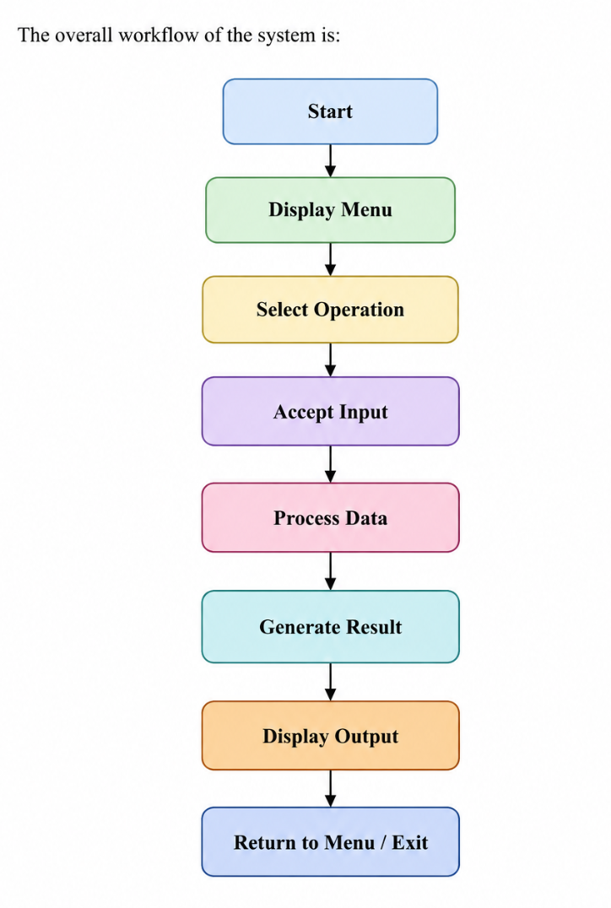
Thus, LIFEOS provides three major functional areas—task management, budget management, and decision support, along with a dedicated What-If Analysis feature. The system has a clear input, processing, and output structure and provides a logical workflow for user interaction.

NON-FUNCTIONAL REQUIREMENTS :

They specify how efficiently, reliably, and conveniently the system should operate.
1. Performance
- The system should process task and budget calculations quickly.
- Priority scores and budget results should be generated immediately after receiving input.
- The system should provide quick responses for normal user operations.
2. Usability
- The system should have a simple and clear console-based interface.
- Menu options should be easy to understand and operate.
- Results should be displayed in a structured and readable format.
3. Reliability
- The system should provide consistent results for valid inputs.
- Budget calculations and task-priority calculations should be accurate.
- The application should continue operating correctly after individual menu operations.
4. Error Handling
- Invalid values should be detected and handled appropriately.
- Negative expense values should not be accepted.
- Invalid menu selections should display a suitable message instead of terminating the application unexpectedly.
- Java exception-handling mechanisms are used where required to improve program robustness.

5. Maintainability
- The system follows a modular object-oriented structure.
- Different responsibilities are separated into classes such as Student, Task, Expense, BudgetManager, DecisionEngine, and WhatIfAnalyzer.
- The modular structure makes the system easier to modify and extend.
6. Resource Efficiency
- The application is designed as a lightweight console-based Java system.
- It requires minimal computational and memory resources.
- Task and expense information are processed using simple data structures and calculations.
7. Scalability
- The modular design allows additional features to be added in the future.
- The system can be extended to support persistent storage, multiple users, advanced scheduling, and intelligent recommendation techniques.

The LIFEOS system focuses on performance, usability, reliability, error handling, maintainability, resource efficiency, and scalability to provide a simple, dependable, and extensible student resource-management application.

SYSTEM ARCHITECTURE :
LIFEOS follows a modular object-oriented architecture in which different classes are responsible for different operations. The system is implemented as a Java-based console application.
1. User Interface Layer
- Provides the console-based menu.
- Accepts user choices and required inputs.
- Displays processed results to the user.
2. Model Layer
This layer represents the data used by the system.
Student
- Stores student information.
- Maintains tasks and expenses.
- Calculates total and remaining budget.
Task
- Stores task details such as name, difficulty, importance, estimated hours, and days remaining.
- Calculates the priority score.
Expense
- Stores expense category and amount.
- Validates expense values.
3. Service Layer
This layer contains the main business logic.
BudgetManager
- Calculates and displays budget information.
DecisionEngine
- Sorts tasks according to priority.
- Generates a study plan based on available hours.
WhatIfAnalyzer
- Calculates the effect of an additional expense.
- Determines whether the expense is affordable.
4. Exception Layer ( InvalidDataException )
Provides a custom exception structure for handling invalid data when required.
Overall Architecture Flow
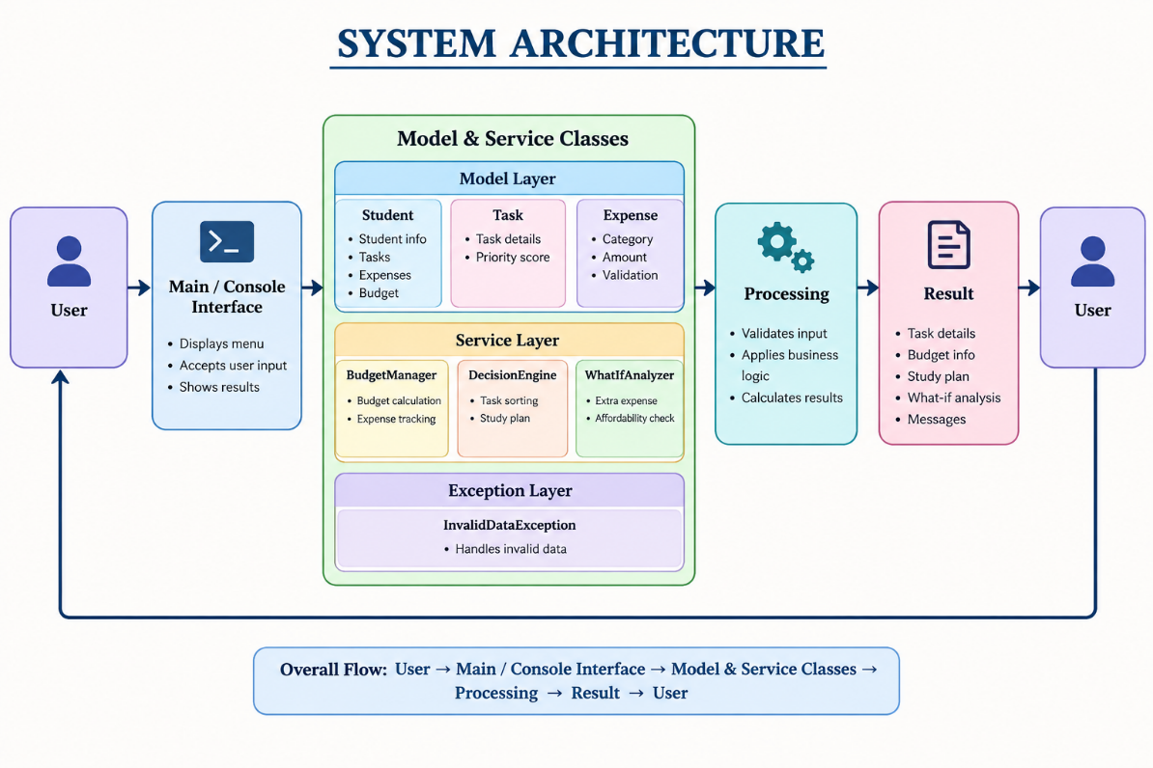

Architecture Benefits
- Separation of responsibilities
- Easy maintenance
- Reusable classes
- Better organization of code

DESIGN DIAGRAMS: USE CASE DIAGRAM :
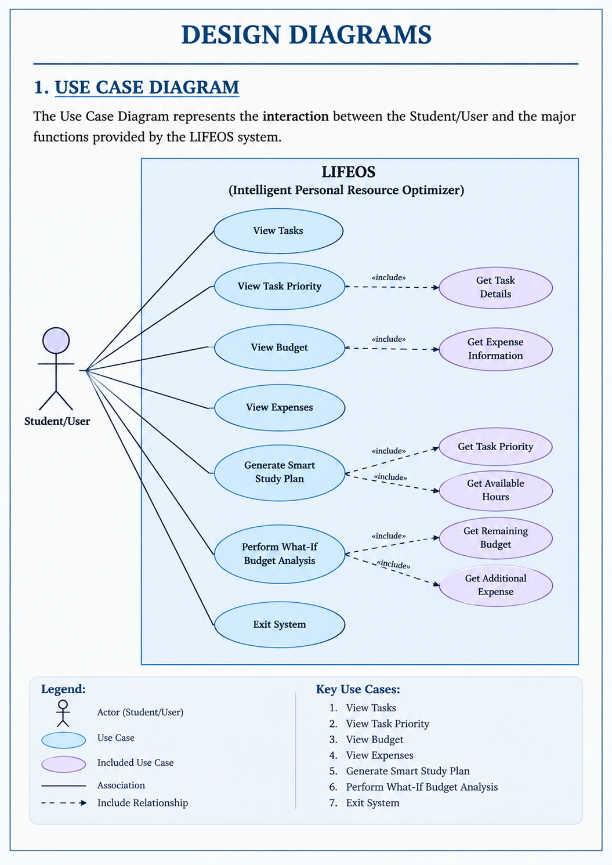

WORKFLOW DIAGRAM :

Flow to include:
START
↓
Launch LIFEOS
↓
Display Main Menu
↓
Select Operation
From the menu:
- Show Tasks → Show Task Details and Priority → Return to Menu
- Show Budget → Calculate Total Expenses and Remaining Budget → Show Result → Return to Menu
- Create Smart Plan → Enter Available Hours → Sort Tasks by Priority → Allocate Available Hours → Show Do/Postpone Plan → Return to Menu
- What-If Analysis → Enter Extra Expense → Calculate Budget After Expense → Check Affordability → Show Result → Return, to Menu
- Exit → END
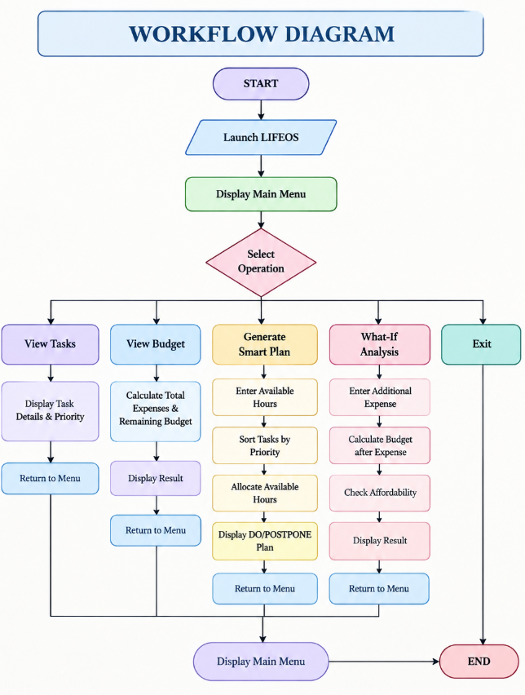

CLASS DIAGRAM :
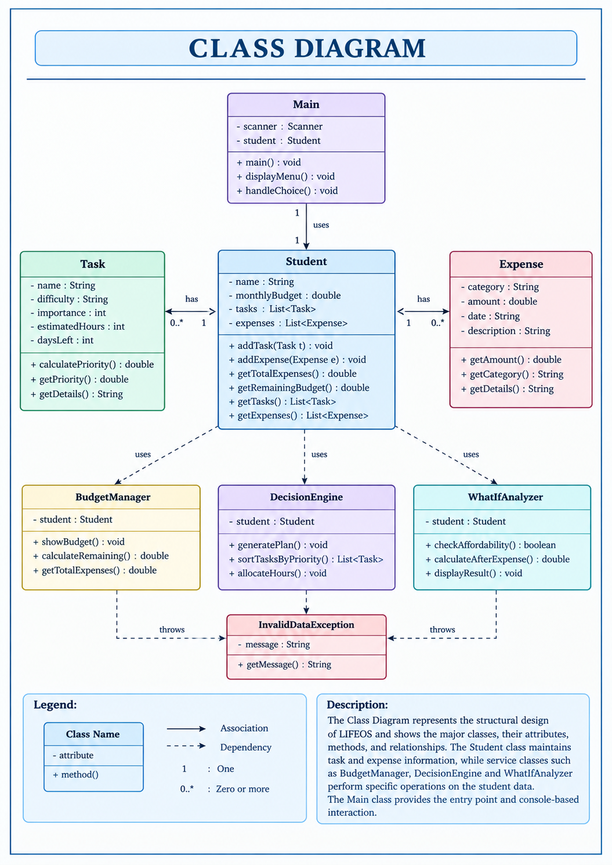
The Class Diagram shows the structure of LIFEOS. The Class Diagram lists the classes, their attributes, methods and relationships. The Student class keeps task information and expense information.
The Student class works with service classes such, as BudgetManager, DecisionEngine and WhatIfAnalyzer. BudgetManager, DecisionEngine and WhatIfAnalyzer perform operations on the Student class data. The Main class gives the entry point. Provides console-based interaction.

DESIGN DECISIONS & RATIONALE :
1. Java as the Development Language
LIFEOS is built using Java. Java is chosen because it supports object-oriented programming. It allows developers to create reusable code. Java also offers platform independence meaning the program can run on any device with a Java Machine. Exception handling in Java helps manage errors. The language includes collections for storing data.. Java supports modular class-based development, which makes the code easier to organize and maintain.
2. Console-Based Interface
The system uses a console-based interface. This choice keeps the focus on Java programming skills. It also focuses on system logic of designing graphical user interfaces. A console interface is simpler and faster to build. It allows developers to test and debug the core functionality without distractions. This approach helps students learn how the system works at a level.
3. Modular Class Structure
The system is organized into classes. Each class has a role. For example the Student class manages student data. The Task class handles task details. The Expense class tracks spending. The BudgetManager class manages finances. The DecisionEngine class makes decisions based on data. The WhatIfAnalyzer class predicts outcomes. This modular design makes the code easier to read. It also makes future changes simpler. Each part can be updated without affecting the others.
4. Priority-Based Task Planning
Tasks are ranked by priority. The priority score considers factors. These include importance, difficulty, estimated completion time, in hours and days left until the deadline. The system uses these values to calculate a priority score. Higher scores mean the task should be done sooner. This helps users decide what to work on first. It ensures important and urgent tasks get attention. The system can adapt to changing conditions and deadlines.
5. Separate Budget Management
Budget-related operations are managed separately using the BudgetManager class. This keeps all calculations separate, from the task-planning logic. It makes it easier to update or change budget rules without affecting how tasks are handled.
6. What-If Analysis
The WhatIfAnalyzer was added to help users see what would happen if an extra expense were introduced. It runs simulations without changing the budget data. This gives students a way to test decisions before committing to them.
7. Collection-Based Data Management
The system uses ArrayList to store tasks and expenses. This allows it to handle any number of entries—whether one or many—. It also makes it easy to add, remove or loop through records as needed.
8. Future Extensibility
The design is built in modules so that new features can be added later. These might include saving data to files connecting to databases using threads, better scheduling options or even smart suggestions powered by AI and machine learning. The structure supports these upgrades without needing a rebuild.

IMPLEMENTATION DETAILS :
1. Development Environment :-
- Programming Language: Java
- Development Environment: Visual Studio Code
- Execution: Java compiler and terminal
- Project Type: Console-based application
2. Project Structure :-
LIFEOS
│
├── Main.java
│
├── model
│ ├── Student.java
│ ├── Task.java
│ └── Expense.java
│
├── service
│ ├── BudgetManager.java
│ ├── DecisionEngine.java
│ └── WhatIfAnalyzer.java
│
└── exception
└── InvalidDataException.java
3. Core Implementation
Student Management:
The Student class keeps Student data such as tasks, expenses and the monthly budget, by using Java objects and an ArrayList.
Task Prioritization:
The Task class determines a priority score by looking at how important a Task's how hard it is how many hours it might take and how many days are left.
Budget Management:
BudgetManager figures out the expenses and the amount of money left and then shows this information.
What-If Analysis:
WhatIfAnalyzer finds out how much money will be left after adding an expense and then shows whether that expense can be paid or if it will go over the budget.
4. Java Concepts Used
- Classes and Objects
- Encapsulation
- Constructors
- Methods
- Access Modifiers
- ArrayList Collections
- Exception Handling
- Comparator and Sorting
- Conditional Statements
- Loops
- Packages and Modular Programming
- Scanner for user input

SCREENSHOTS / RESULTS :
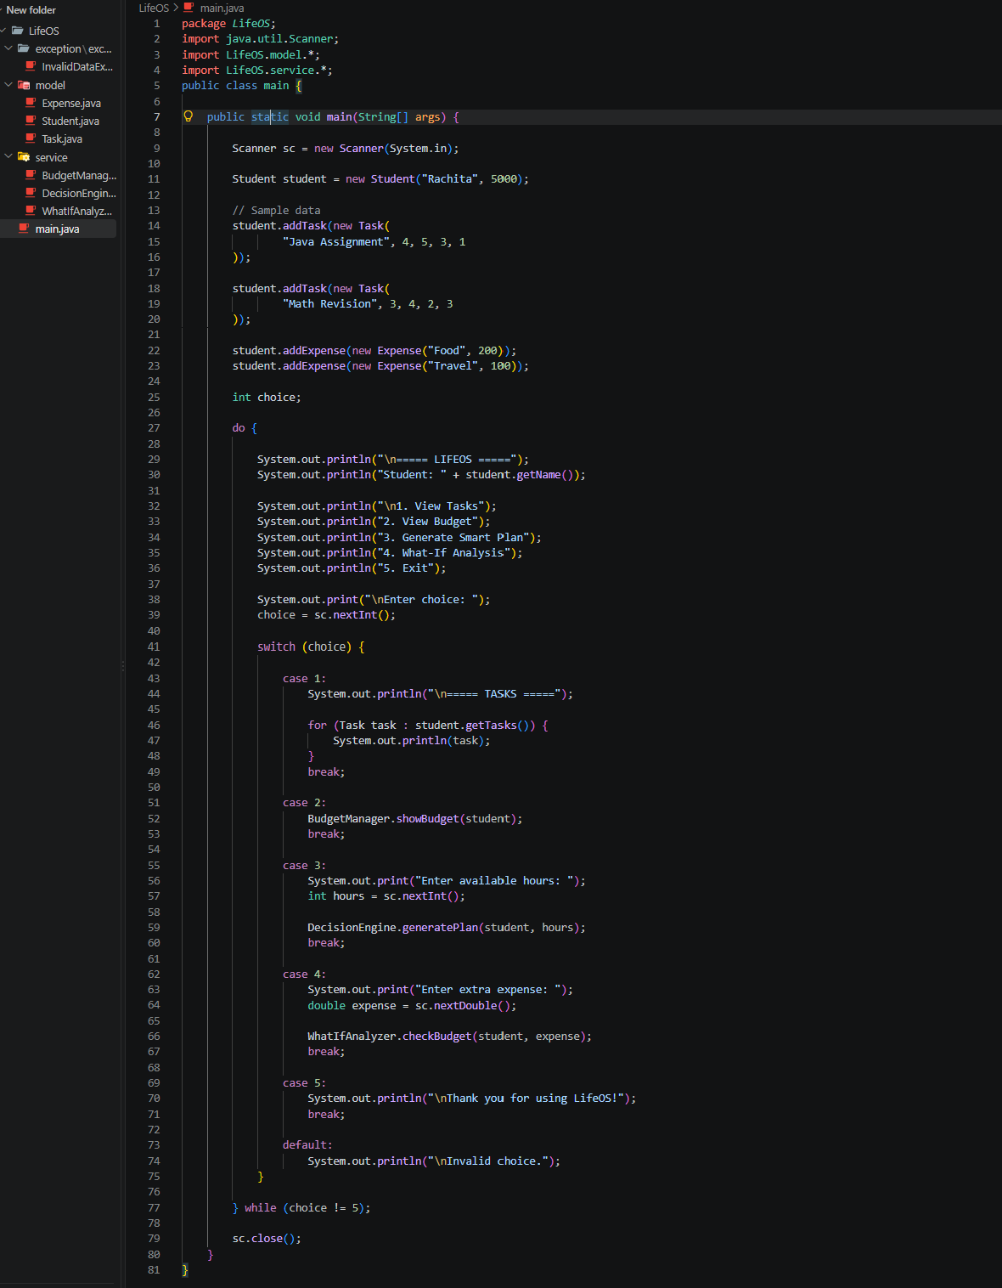

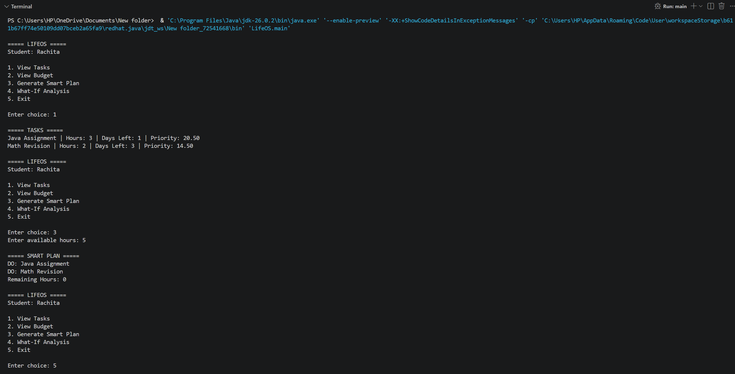

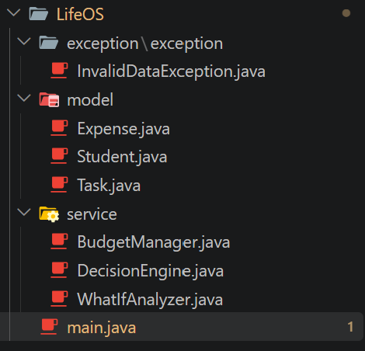

TESTING APPROACH :
1. Functional Testing :-
Test Case | Input / Operation | Expected Result
TC-01 | View Tasks | Displays task details and priority scores
TC-02 | View Budget | Displays budget, total expenses and remaining amount
TC-03 | Generate Smart Plan | Selects tasks according to priority and available hours
TC-04 | What-If Analysis | Calculates budget after additional expense
TC-05 | Extra expense within budget | Displays affordable decision
TC-06 | Extra expense greater than budget | Displays budget exceeded warning
TC-07 | Invalid menu choice | Displays invalid-choice message

2. Input Validation Testing
The system was tested with different input values to ensure that incorrect or invalid data does not produce incorrect calculations.
Examples tested:
- Valid menu choices
- Different available study hours
- Different additional expense amounts
- Negative task or expense values

3. Boundary Testing
Boundary cases were considered, such as:
- 0 available study hours
- An expense equal to the remaining budget
- An expense greater than the remaining budget
- Tasks requiring more hours than currently available

4. Result Verification
The calculated outputs were manually checked against expected values to verify:
- Task priority calculation
- Total expense calculation
- Remaining budget
- Smart-plan allocation
- What-If budget calculation

The major implemented functions of LIFEOS were tested using different input conditions. The results demonstrated that the system correctly performs task prioritization, budget calculation, smart planning, and What-If analysis for the tested scenarios.

CHALLENGES FACED :
When I worked on LIFEOS – Intelligent Personal Resource Optimizer I faced challenges while designing, implementing and testing the Java application.
1. Managing Multiple Java Classes
I had to split the project into model, service and exception packages. Managing the Java classes and package declarations required care.
The Java application needed each class in the package to stay organized.
2. Package and File Structure
Keeping the folder names, package declarations and Java class files in sync was hard at first.
I had to make sure the Java application was properly organized so that compilation errors would not happen.
3. Input Handling
Using the Scanner class for console input made me think carefully about input types, such, as integers and decimal values.
If the user typed something the Java application could throw exceptions like InputMismatchException. I had to guard against that.
4. Task Priority Calculation
Creating a priority calculation meant I had to combine several factors. I considered importance, difficulty, estimated hours and days remaining to give the Java application a way to rank tasks.
5. Smart Plan Generation
The system had to figure out which tasks could fit into the user’s hours and needed to sort tasks by how important they were and then assign time slots based on that order.
This required thinking and logical steps to make sure everything made sense.
LEARNINGS & KEY TAKEAWAYS :
The development of LIFEOS – Intelligent Personal Resource Optimizer provided practical experience in applying Java programming concepts to a real-world problem.
1.Object-Oriented Programming :-
Learned how to design a system using classes, objects, encapsulation, constructors, methods, and access modifiers.
2. Modular Programming :-
Understood the importance of dividing a project into separate model, service, and exception packages to improve organization and maintainability.
3. Collections in Java :-
Gained practical knowledge of using ArrayList to store and manage multiple tasks and expenses dynamically.
4. Exception and Input Handling :-
Learned to validate user data and handle invalid values using Java's exception-handling mechanisms.
5. Sorting and Decision Making :-
Learned how to use Comparator and sorting techniques to arrange tasks according to their calculated priority.
6. Problem-Solving Skills
- Task priority calculation
- Study-hour allocation
- Budget calculation
- What-If financial analysis
7. Debugging and Testing
Gained practical experience in identifying and fixing compilation errors, package-related errors, input errors, and logical errors during development.
8. Software Design Understanding
Developed an understanding of how requirements can be converted into architecture, class diagrams, workflows, implementation, and testing.

FUTURE ENHANCEMENTS :
The current version of LIFEOS provides the basic functionality required for student time and budget management. The system can be further improved by adding the following features:
1. Persistent Data Storage
Task, expense, and student information can be stored using files or a database so that data remains available after the program is closed.
2. User Authentication
A login and user-management system can be introduced to support multiple students and protect personal data.
3. Advanced Task Scheduling
The system can be enhanced with calendar-based scheduling, recurring tasks, deadline reminders, and more advanced time-allocation algorithms.
4. Graphical User Interface
A user-friendly GUI or web/mobile interface can be developed to make LIFEOS easier to use than the current console-based interface.
5. Data Visualization
Charts and graphs can be added to display:
- Monthly expenses
- Budget utilization
- Task completion
- Study-time allocation

6. AI-Based Recommendations
Future versions could use AI/ML techniques to provide personalized study plans, predict workload, and recommend better resource allocation.

7. Notifications and Reminders
Deadline alerts, budget warnings, and scheduled study reminders can be added.

REFERENCES :
The following resources were referred to during the development and documentation of LIFEOS – Intelligent Personal Resource Optimizer:
- Oracle Java Documentation — Java language concepts, classes, objects, exception handling, collections, and standard libraries.
- Java Platform Documentation — Reference material for Java APIs, ArrayList, Scanner, Comparator, and related classes.
- Visual Studio Code Documentation — Used as a reference for Java development and project organization in the development environment.
- GeeksforGeeks — Reference material for Java programming concepts, object-oriented programming, collections, sorting, and exception handling.
- Project Source Code Repository — LIFEOS source code, project structure, implementation, and development files.

